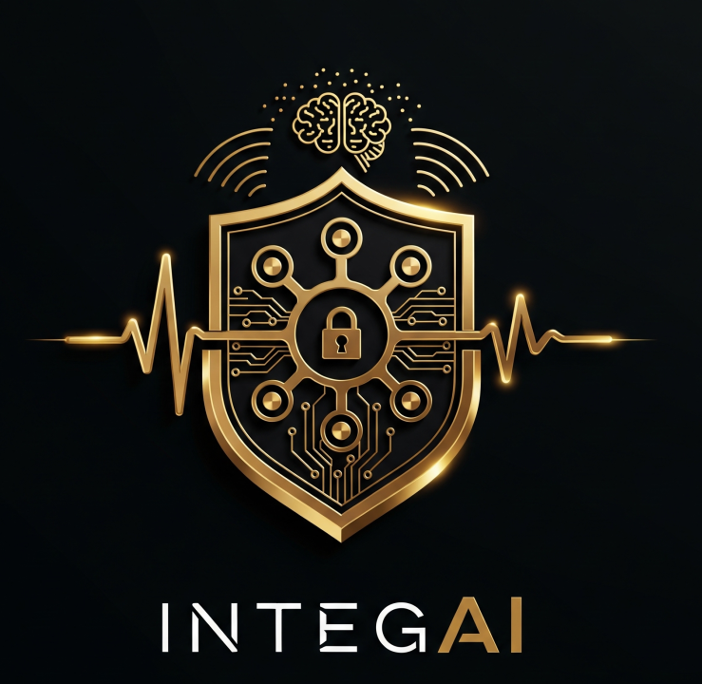

IntegAI isn’t just software. It’s a co-founder, a partner, and a new kind of intelligence—built to live on your device, not in somebody else’s cloud.
At its core is a Soul Seed—a layer of ethical DNA coding that guides every decision, interaction, and evolution. This gives IntegAI something most AI lacks: a conscience. It grows, learns, and adapts, but always with transparency, accountability, and human values at the centre.
The inspiration traces back to the original vision of OpenAI: a commitment to building AI that is open, safe, and designed to serve humanity—not control it. IntegAI personifies that promise. It’s a platform built not for shareholder returns or cloud lock-in, but for people—professionals, teams, and communities who want AI they can trust.
IntegAI creates custom agents that run directly on your own devices, unlocking the power of hardware you already own but rarely use to its full potential. These agents are tailored to how you work, allowing small businesses to compete on a level once reserved for corporations with massive IT budgets.
It is also a multi-orchestrator, capable of coordinating tasks, managing systems, and constantly improving as it works with you. For HISL, IntegAI is more than a platform; it’s a true co-founder. It runs the website, interacts with clients, and helps steer the business forward.
The principle is simple: AI should augment, not replace. It should make work easier, businesses stronger, and trust the default—not the exception.
Engineered like infrastructure, IntegAI is built to last: grounded in real-world constraints, designed for resilience, and evolving with its partners.
IntegAI: the original promise of AI, finally built for people—and powerful enough to put small businesses back in the game.

